TestRail
Session 1 – Foundations + Core Hands-On
Day 1: TestRail Basics & Positioning
Learnt
- What TestRail is and why companies use it
TestRail is a test management tool used to:
- Design test cases
- Organize them by feature/module
- Execute tests for releases/sprints
- Track results and quality metrics
- Provide audit-ready test evidence (very important for Veeva)
- TestRail vs Xray vs Jira (high-level)
- Where TestRail fits in Agile testing
- Core terminology:
  - Project
  - Test Suite
  - Test Case
  - Test Run
  - Test Plan
Practical
- Logged into TestRail
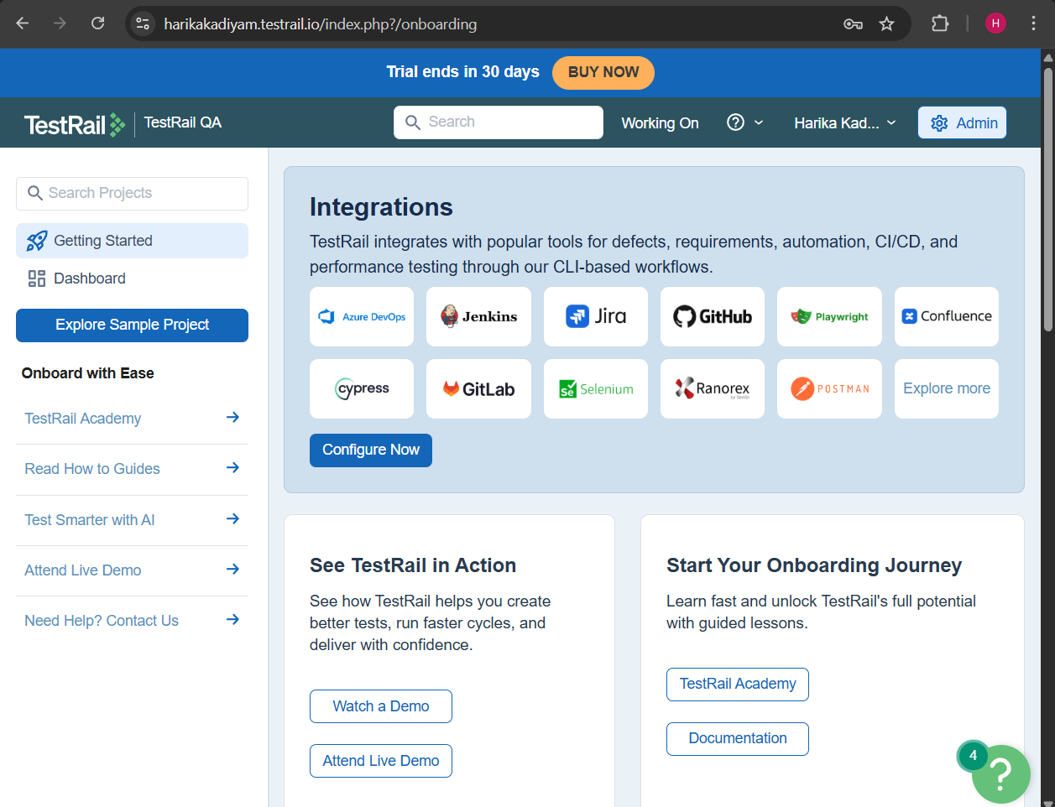
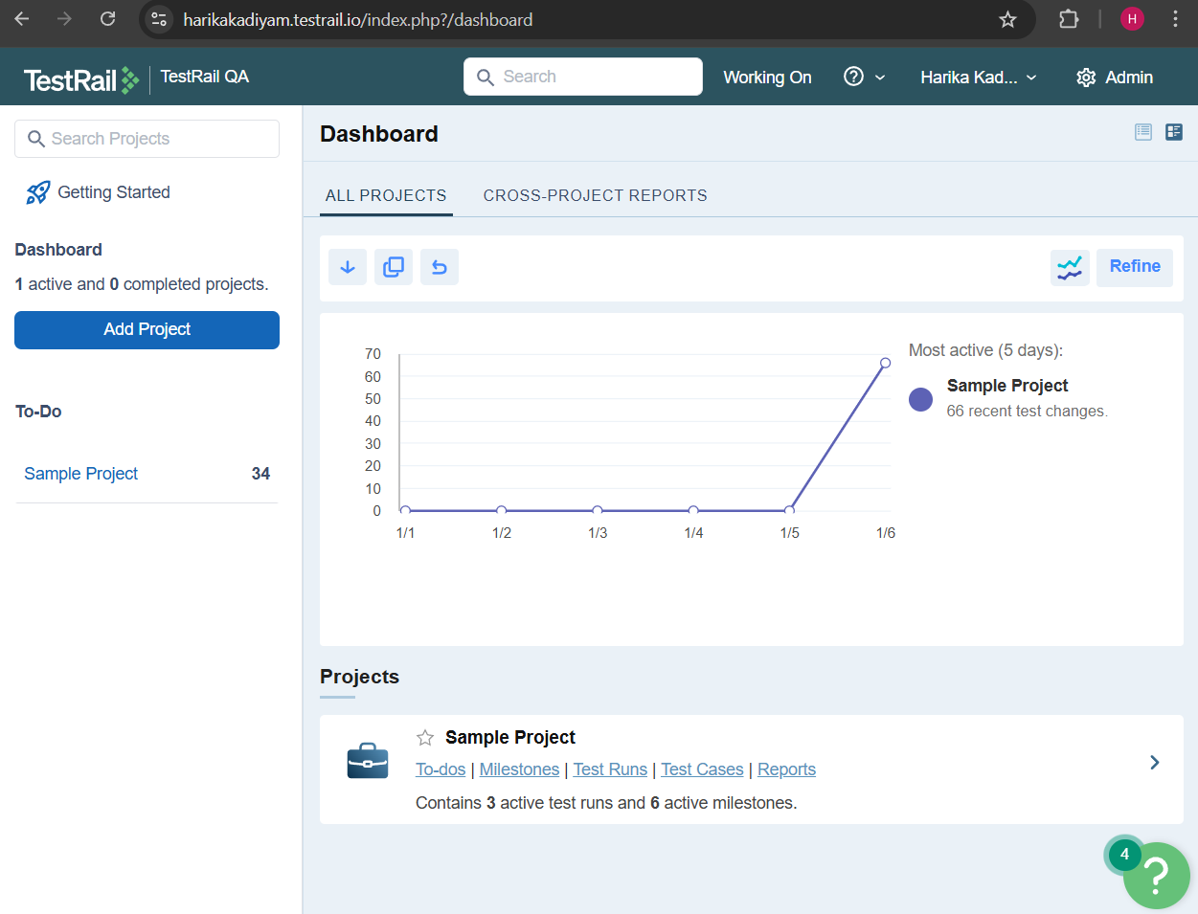
- Created a Project
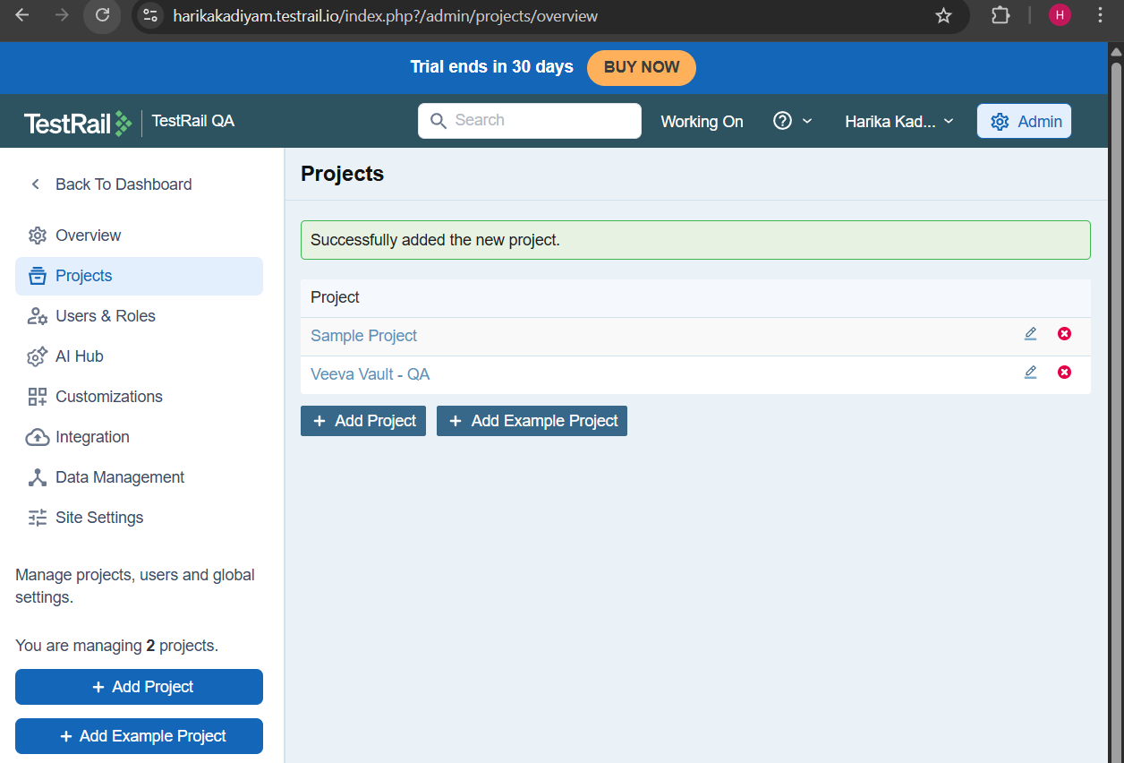
- Chose project type:
  - Single Repository (preferred)
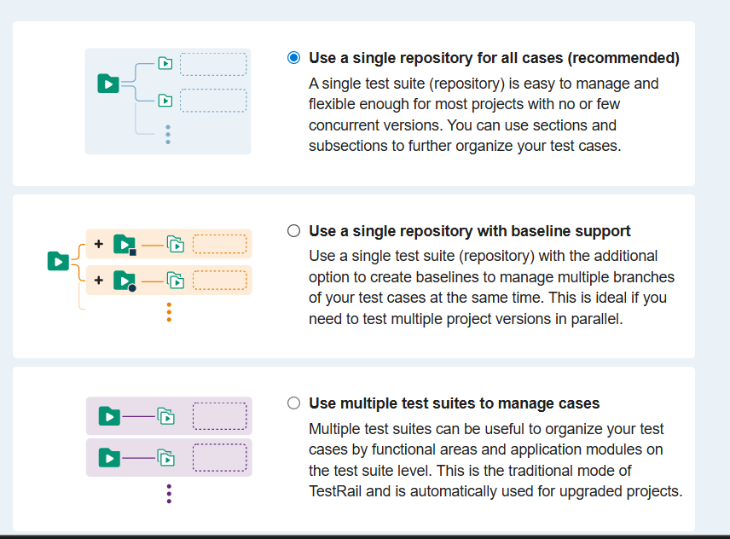
- Explored:
  - Dashboard
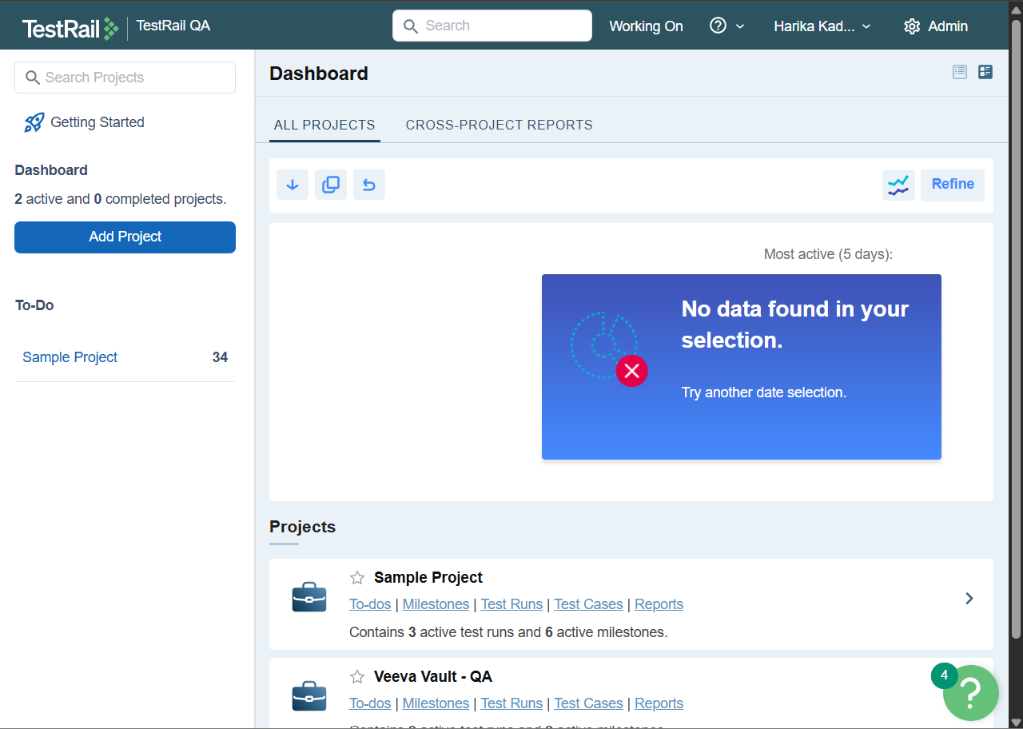
  - Test Cases
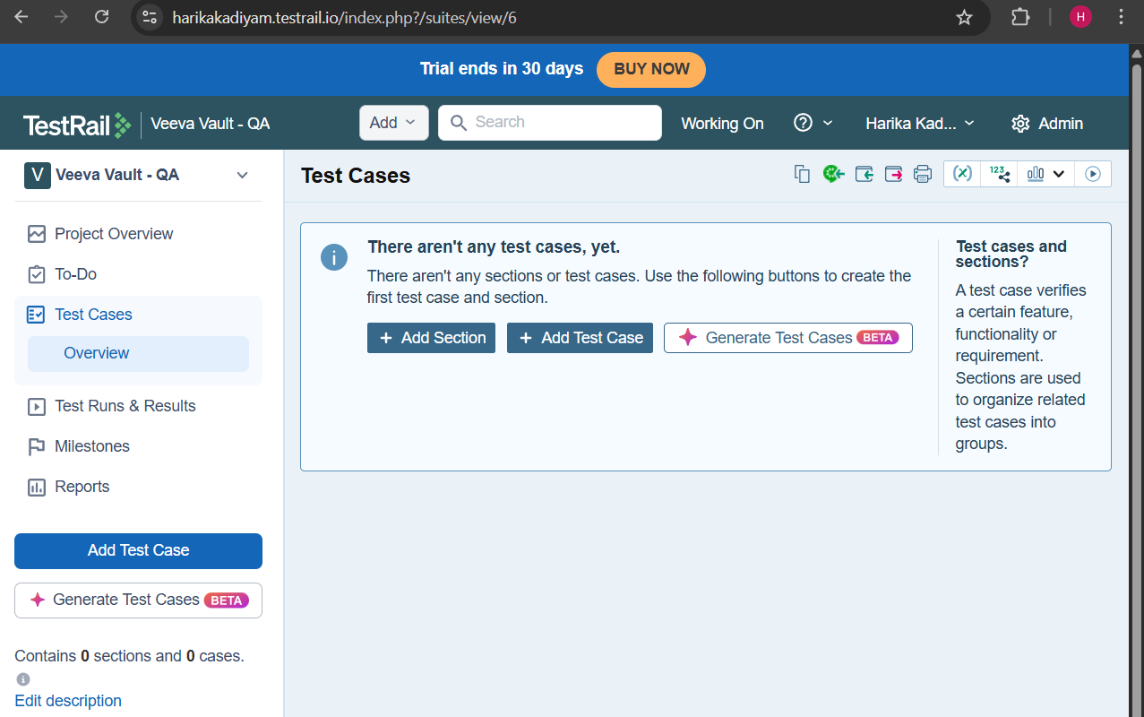
  - Test Runs & Results
